

Talha Abdullah Bangyal
22F-3194
BS (AI) - 3A
LAB 3

Task 1
#include<iostream>
using namespace std;

struct Node {
int data;
Node* next;
};

class SinglyLinkedList {
public:
SinglyLinkedList();
void Insert_at_front(int val);
void Insert_at_end(int val);
void Insert_at_index(int index, int val);
void Delete_at_front();
void Delete_at_end();
void Delete_at_index(int index);
bool Isempty();
void Print();
~SinglyLinkedList();

private:
Node* head;
};

SinglyLinkedList::SinglyLinkedList() {
head = NULL;
}

bool SinglyLinkedList::Isempty() {
return head == NULL;
}

void SinglyLinkedList::Insert_at_front(int val) {
if (Isempty()) {
head = new Node;
head->data = val;
head->next = NULL;
}
else {
Node* temp = new Node;
temp->data = val;
temp->next = head;
head = temp;
}
}

void SinglyLinkedList::Insert_at_end(int val) {
if (Isempty()) {
head = new Node;
head->data = val;
head->next = NULL;
}
else {
Node* current = head;
while (current->next != NULL) {
current = current->next;
}
Node* temp = new Node;
temp->data = val;
temp->next = NULL;
current->next = temp;
}
}

void SinglyLinkedList::Insert_at_index(int index, int val) {
if (Isempty()) {
if (index == 0) {
head = new Node;
head->data = val;
head->next = NULL;
}
else {
cout << "Index out of bounds" << endl;
return;
}
}
else {
Node* current = head;
int currentIndex = 0;
while (current->next != NULL && currentIndex < index - 1) {
current = current->next;
currentIndex++;
}
if (currentIndex == index - 1) {
Node* newNode = new Node;
newNode->data = val;
newNode->next = current->next;
current->next = newNode;
}
else {
cout << "Index out of bounds" << endl;
}
}
}

void SinglyLinkedList::Delete_at_front() {
if (Isempty()) {
cout << "List is empty" << endl;
return;
}
else {
Node* temp = head;
head = head->next;
delete temp;
}
}

void SinglyLinkedList::Delete_at_end() {
if (Isempty()) {
cout << "List is empty" << endl;
return;
}
else if (head->next == NULL) {
delete head;
head = NULL;
}
else {
Node* current = head;
while (current->next->next != NULL) {
current = current->next;
}
delete current->next;
current->next = NULL;
}
}

void SinglyLinkedList::Delete_at_index(int index) {
if (Isempty()) {
cout << "List is empty" << endl;
return;
}
else if (index == 0) {
Node* temp = head;
head = head->next;
delete temp;
}
else {
Node* current = head;
int currentIndex = 0;
while (current->next != NULL && currentIndex < index - 1) {
current = current->next;
currentIndex++;
}
if (currentIndex == index - 1) {
Node* temp = current->next;
current->next = current->next->next;
delete temp;
}
else {
cout << "Index out of bounds" << endl;
}
}
}

void SinglyLinkedList::Print() {
Node* current = head;
while (current != NULL) {
cout << current->data << " ";
current = current->next;
}
cout << endl;
}

SinglyLinkedList::~SinglyLinkedList() {
Node* current = head;
while (current != NULL) {
Node* next = current->next;
delete current;
current = next;
}
}

int main() {
SinglyLinkedList SSL;
int choice, val, index;

while (true) {
cout << "------------------------Menu--------------------------" << endl;
cout << "1. Insert at front" << endl;
cout << "2. Insert at end" << endl;
cout << "3. Insert at index" << endl;
cout << "4. Delete at front" << endl;
cout << "5. Delete at end" << endl;
cout << "6. Delete at index" << endl;
cout << "7. Print list" << endl;
cout << "0. Exit" << endl;
cout << "Enter your choice: ";
cin >> choice;

switch (choice) {
case 1:
cout << "Enter value to insert at front: ";
cin >> val;
SSL.Insert_at_front(val);
break;
case 2:
cout << "Enter value to insert at end: ";
cin >> val;
SSL.Insert_at_end(val);
break;
case 3:
cout << "Enter index: ";
cin >> index;
cout << "Enter value to insert: ";
cin >> val;
SSL.Insert_at_index(index, val);
break;
case 4:
SSL.Delete_at_front();
break;
case 5:
SSL.Delete_at_end();
break;
case 6:
cout << "Enter index: ";
cin >> index;
SSL.Delete_at_index(index);
break;
case 7:
SSL.Print();
break;
case 0:
return 0;
default:
cout << "Invalid choice. Try again." << endl;
}
}

return 0;
}
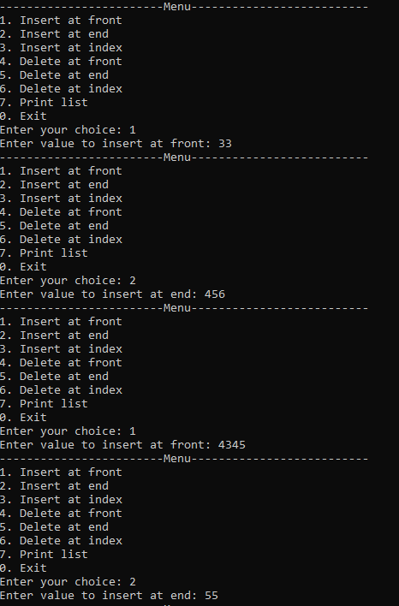
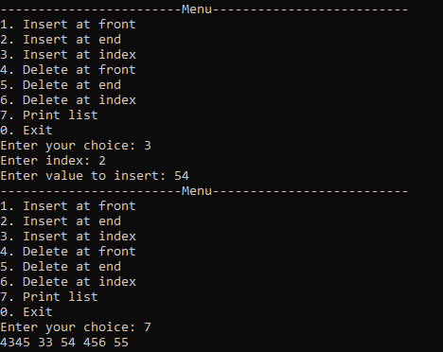
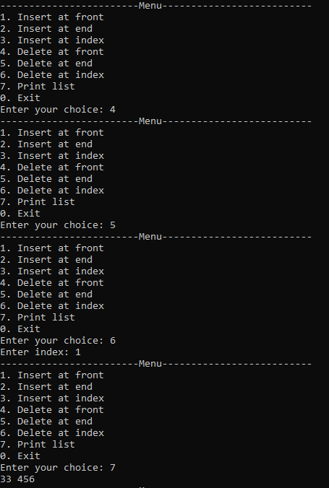
Task 2
#include<iostream>
using namespace std;

struct Node {
int data;
Node* next;
Node* prev;
};

class DoublyLinkedList {
public:
DoublyLinkedList();
void Insert_at_front(int val);
void Insert_at_end(int val);
void Insert_at_index(int index, int val);
void Delete_at_front();
void Delete_at_end();
void Delete_at_index(int index);
bool Isempty();
void Print();
~DoublyLinkedList();

private:
Node* head;
Node* tail;
};

DoublyLinkedList::DoublyLinkedList() {
head = NULL;
tail = NULL;
}

bool DoublyLinkedList::Isempty() {
return head == NULL;
}

void DoublyLinkedList::Insert_at_front(int val) {
if (Isempty()) {
head = new Node;
head->data = val;
head->next = NULL;
head->prev = NULL;
tail = head;
}
else {
Node* temp = new Node;
temp->data = val;
temp->next = head;
head->prev = temp;
temp->prev = NULL;
head = temp;
}
}

void DoublyLinkedList::Insert_at_end(int val) {
if (Isempty()) {
head = new Node;
head->data = val;
head->next = NULL;
head->prev = NULL;
tail = head;
}
else {
Node* temp = new Node;
temp->data = val;
temp->next = NULL;
temp->prev = tail;
tail->next = temp;
tail = temp;
}
}

void DoublyLinkedList::Insert_at_index(int index, int val) {
if (Isempty()) {
if (index == 0) {
head = new Node;
head->data = val;
head->next = NULL;
head->prev = NULL;
tail = head;
}
else {
cout << "Index out of bounds" << endl;
return;
}
}
else {
Node* current = head;
int currentIndex = 0;
while (current->next != NULL && currentIndex < index - 1) {
current = current->next;
currentIndex++;
}
if (currentIndex == index - 1) {
Node* newNode = new Node;
newNode->data = val;
newNode->next = current->next;
newNode->prev = current;
current->next = newNode;
if (newNode->next != NULL) {
newNode->next->prev = newNode;
}
else {
tail = newNode;
}
}
else {
cout << "Index out of bounds" << endl;
}
}
}

void DoublyLinkedList::Delete_at_front() {
if (Isempty()) {
cout << "List is empty" << endl;
return;
}
else {
Node* temp = head;
head = head->next;
if (head != NULL) {
head->prev = NULL;
}
else {
tail = NULL;
}
delete temp;
}
}

void DoublyLinkedList::Delete_at_end() {
if (Isempty()) {
cout << "List is empty" << endl;
return;
}
else if (head->next == NULL) {
delete head;
head = NULL;
tail = NULL;
}
else {
Node* current = head;
while (current->next->next != NULL) {
current = current->next;
}
Node* temp = current->next;
current->next = NULL;
tail = current;
delete temp;
}
}

void DoublyLinkedList::Delete_at_index(int index) {
if (Isempty()) {
cout << "List is empty" << endl;
return;
}

if (index < 0) {
cout << "Index cannot be negative" << endl;
return;
}

if (index == 0) {
Node* temp = head;
head = head->next;
if (head != nullptr) {
head->prev = nullptr;
}
else {
tail = nullptr;
}
delete temp;
}
else {
Node* current = head;
int currentIndex = 0;

while (current != nullptr && currentIndex < index - 1) {
current = current->next;
currentIndex++;
}

if (current == nullptr || current->next == nullptr) {
cout << "Index out of bounds" << endl;
return;
}
Node* temp = current->next;
current->next = temp->next;
if (temp->next != nullptr) {
temp->next->prev = current;
}
else {
tail = current;
}
delete temp;
}
}
void DoublyLinkedList::Print() {
Node* current = head;
while (current != NULL) {
cout << current->data << " ";
current = current->next;
}
cout << endl;
}

DoublyLinkedList::~DoublyLinkedList() {
Node* current = head;
while (current != NULL) {
Node* next = current->next;
delete current;
current = next;
}
}

int main() {
DoublyLinkedList DLL;
int choice, val, index;

while (true) {
cout << "------------------------Menu--------------------------" << endl;
cout << "1. Insert at front" << endl;
cout << "2. Insert at end" << endl;
cout << "3. Insert at index" << endl;
cout << "4. Delete at front" << endl;
cout << "5. Delete at end" << endl;
cout << "6. Delete at index" << endl;
cout << "7. Print list" << endl;
cout << "0. Exit" << endl;
cout << "Enter your choice: ";
cin >> choice;

switch (choice) {
case 1:
cout << "Enter value to insert at front: ";
cin >> val;
DLL.Insert_at_front(val);
break;
case 2:
cout << "Enter value to insert at end: ";
cin >> val;
DLL.Insert_at_end(val);
break;
case 3:
cout << "Enter index: ";
cin >> index;
cout << "Enter value to insert: ";
cin >> val;
DLL.Insert_at_index(index, val);
break;
case 4:
DLL.Delete_at_front();
break;
case 5:
DLL.Delete_at_end();
break;
case 6:
cout << "Enter index: ";
cin >> index;
DLL.Delete_at_index(index);
break;
case 7:
DLL.Print();
break;
case 0:
return 0;
default:
cout << "Invalid choice. Try again." << endl;
}
}

return 0;
}
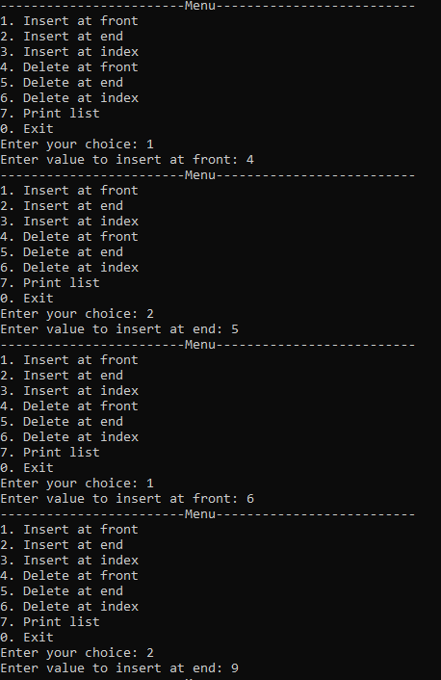
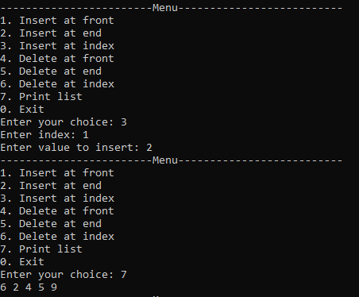
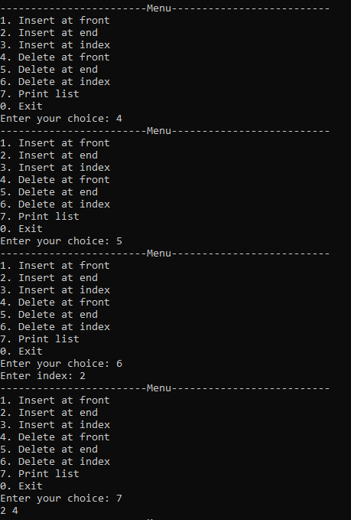
Task 3
#include<iostream>
using namespace std;

struct Node {
int data;
Node* next;
Node* prev;
};

class DoublyLinkedList {
public:
DoublyLinkedList();
void Insert_at_front(int val);
void Insert_at_end(int val);
void Insert_at_index(int index, int val);
void Delete_at_front();
void Delete_at_end();
void Delete_at_index(int index);
void reverseDoubly();
bool Isempty();
void Print();
~DoublyLinkedList();

private:
Node* head;
Node* tail;
};

DoublyLinkedList::DoublyLinkedList() {
head = NULL;
tail = NULL;
}

bool DoublyLinkedList::Isempty() {
return head == NULL;
}

void DoublyLinkedList::Insert_at_front(int val) {
if (Isempty()) {
head = new Node;
head->data = val;
head->next = NULL;
head->prev = NULL;
tail = head;
}
else {
Node* temp = new Node;
temp->data = val;
temp->next = head;
head->prev = temp;
temp->prev = NULL;
head = temp;
}
}

void DoublyLinkedList::Insert_at_end(int val) {
if (Isempty()) {
head = new Node;
head->data = val;
head->next = NULL;
head->prev = NULL;
tail = head;
}
else {
Node* temp = new Node;
temp->data = val;
temp->next = NULL;
temp->prev = tail;
tail->next = temp;
tail = temp;
}
}

void DoublyLinkedList::Insert_at_index(int index, int val) {
if (Isempty()) {
if (index == 0) {
head = new Node;
head->data = val;
head->next = NULL;
head->prev = NULL;
tail = head;
}
else {
cout << "Index out of bounds" << endl;
return;
}
}
else {
Node* current = head;
int currentIndex = 0;
while (current->next != NULL && currentIndex < index - 1) {
current = current->next;
currentIndex++;
}
if (currentIndex == index - 1) {
Node* newNode = new Node;
newNode->data = val;
newNode->next = current->next;
newNode->prev = current;
current->next = newNode;
if (newNode->next != NULL) {
newNode->next->prev = newNode;
}
else {
tail = newNode;
}
}
else {
cout << "Index out of bounds" << endl;
}
}
}

void DoublyLinkedList::Delete_at_front() {
if (Isempty()) {
cout << "List is empty" << endl;
return;
}
else {
Node* temp = head;
head = head->next;
if (head != NULL) {
head->prev = NULL;
}
else {
tail = NULL;
}
delete temp;
}
}

void DoublyLinkedList::Delete_at_end() {
if (Isempty()) {
cout << "List is empty" << endl;
return;
}
else if (head->next == NULL) {
delete head;
head = NULL;
tail = NULL;
}
else {
Node* current = head;
while (current->next->next != NULL) {
current = current->next;
}
Node* temp = current->next;
current->next = NULL;
tail = current;
delete temp;
}
}

void DoublyLinkedList::Delete_at_index(int index) {
if (Isempty()) {
cout << "List is empty" << endl;
return;
}

if (index < 0) {
cout << "Index cannot be negative" << endl;
return;
}

if (index == 0) {
Node* temp = head;
head = head->next;
if (head != nullptr) {
head->prev = nullptr;
}
else {
tail = nullptr;
}
delete temp;
}
else {
Node* current = head;
int currentIndex = 0;

while (current != nullptr && currentIndex < index - 1) {
current = current->next;
currentIndex++;
}

if (current == nullptr || current->next == nullptr) {
cout << "Index out of bounds" << endl;
return;
}
Node* temp = current->next;
current->next = temp->next;
if (temp->next != nullptr) {
temp->next->prev = current;
}
else {
tail = current;
}
delete temp;
}
}

void DoublyLinkedList::reverseDoubly() {
Node* current = head;
Node* temp = NULL;

while (current != NULL) {
temp = current->next;
current->next = current->prev;
current->prev = temp;
current = temp;
}

temp = head;
head = tail;
tail = temp;
}

void DoublyLinkedList::Print() {
Node* current = head;
while (current != NULL) {
cout << current->data << " ";
current = current->next;
}
cout << endl;
}

DoublyLinkedList::~DoublyLinkedList() {
Node* current = head;
while (current != NULL) {
Node* next = current->next;
delete current;
current = next;
}
}

int main() {
DoublyLinkedList DLL;
int choice, val, index;

while (true) {
cout << "------------------------Menu--------------------------" << endl;
cout << "1. Insert at front" << endl;
cout << "2. Insert at end" << endl;
cout << "3. Insert at index" << endl;
cout << "4. Delete at front" << endl;
cout << "5. Delete at end" << endl;
cout << "6. Delete at index" << endl;
cout << "7. reverse list" << endl;
cout << "8. Print list" << endl;
cout << "0. Exit" << endl;
cout << "Enter your choice: ";
cin >> choice;

switch (choice) {
case 1:
cout << "Enter value to insert at front: ";
cin >> val;
DLL.Insert_at_front(val);
break;
case 2:
cout << "Enter value to insert at end: ";
cin >> val;
DLL.Insert_at_end(val);
break;
case 3:
cout << "Enter index: ";
cin >> index;
cout << "Enter value to insert: ";
cin >> val;
DLL.Insert_at_index(index, val);
break;
case 4:
DLL.Delete_at_front();
break;
case 5:
DLL.Delete_at_end();
break;
case 6:
cout << "Enter index: ";
cin >> index;
DLL.Delete_at_index(index);
break;
case 7:
DLL.reverseDoubly();
break;
case 8:
DLL.Print();
break;
case 0:
return 0;
default:
cout << "Invalid choice. Try again." << endl;
}
}

return 0;
}
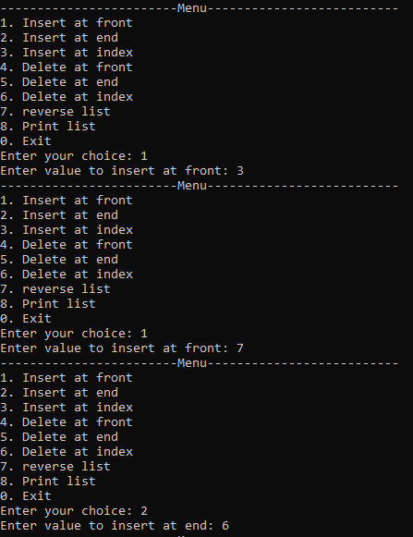
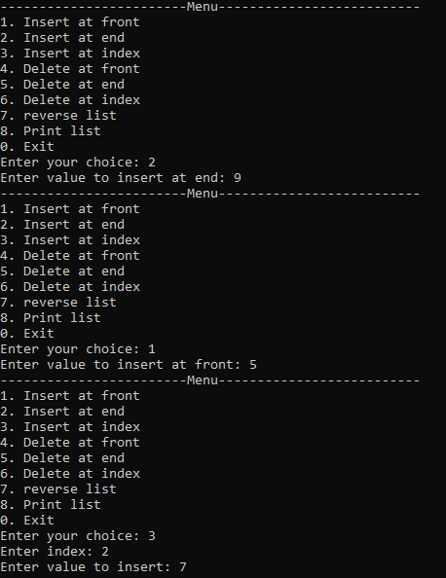
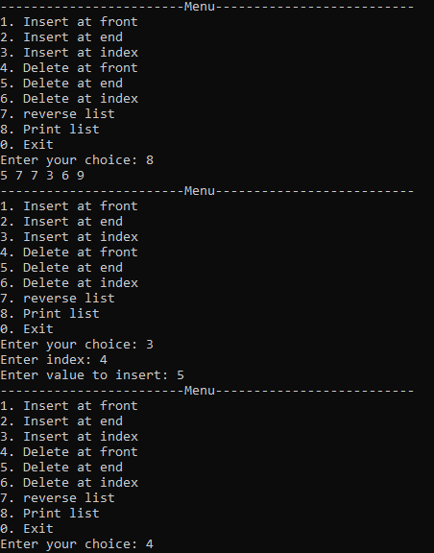
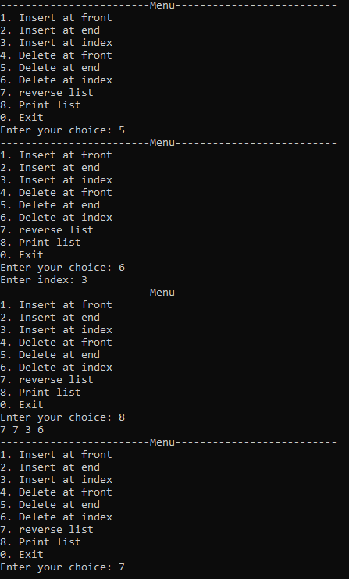
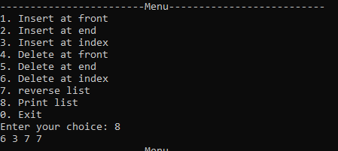
Task 4
#include<iostream>
using namespace std;

struct Node {
int data;
Node* next;
};

class SinglyLinkedList {
public:
SinglyLinkedList();
void Insert_at_front(int val);
void Insert_at_end(int val);
void Insert_at_index(int index, int val);
void Delete_at_front();
void Delete_at_end();
void Delete_at_index(int index);
void rotateSingly(int K);
bool Isempty();
void Print();
~SinglyLinkedList();

private:
Node* head;
};

SinglyLinkedList::SinglyLinkedList() {
head = NULL;
}

bool SinglyLinkedList::Isempty() {
return head == NULL;
}

void SinglyLinkedList::Insert_at_front(int val) {
if (Isempty()) {
head = new Node;
head->data = val;
head->next = NULL;
}
else {
Node* temp = new Node;
temp->data = val;
temp->next = head;
head = temp;
}
}

void SinglyLinkedList::Insert_at_end(int val) {
if (Isempty()) {
head = new Node;
head->data = val;
head->next = NULL;
}
else {
Node* current = head;
while (current->next != NULL) {
current = current->next;
}
Node* temp = new Node;
temp->data = val;
temp->next = NULL;
current->next = temp;
}
}

void SinglyLinkedList::Insert_at_index(int index, int val) {
if (Isempty()) {
if (index == 0) {
head = new Node;
head->data = val;
head->next = NULL;
}
else {
cout << "Index out of bounds" << endl;
return;
}
}
else {
Node* current = head;
int currentIndex = 0;
while (current->next != NULL && currentIndex < index - 1) {
current = current->next;
currentIndex++;
}
if (currentIndex == index - 1) {
Node* newNode = new Node;
newNode->data = val;
newNode->next = current->next;
current->next = newNode;
}
else {
cout << "Index out of bounds" << endl;
}
}
}

void SinglyLinkedList::Delete_at_front() {
if (Isempty()) {
cout << "List is empty" << endl;
return;
}
else {
Node* temp = head;
head = head->next;
delete temp;
}
}

void SinglyLinkedList::Delete_at_end() {
if (Isempty()) {
cout << "List is empty" << endl;
return;
}
else if (head->next == NULL) {
delete head;
head = NULL;
}
else {
Node* current = head;
while (current->next->next != NULL) {
current = current->next;
}
delete current->next;
current->next = NULL;
}
}

void SinglyLinkedList::Delete_at_index(int index) {
if (Isempty()) {
cout << "List is empty" << endl;
return;
}
else if (index == 0) {
Node* temp = head;
head = head->next;
delete temp;
}
else {
Node* current = head;
int currentIndex = 0;
while (current->next != NULL && currentIndex < index - 1) {
current = current->next;
currentIndex++;
}
if (currentIndex == index - 1) {
Node* temp = current->next;
current->next = current->next->next;
delete temp;
}
else {
cout << "Index out of bounds" << endl;
}
}
}

void SinglyLinkedList::rotateSingly(int K) {
if (Isempty()) {
cout << "List is empty" << endl;
return;
}

int length = 0;
Node* current = head;
while (current != NULL) {
length++;
current = current->next;
}

K = K % length; // handle cases where K is greater than the length of the list

if (K == 0) {
return; // no rotation needed
}

Node* newTail = head;
for (int i = 0; i < length - K - 1; i++) {
newTail = newTail->next;
}

Node* newHead = newTail->next;
newTail->next = NULL;

Node* current2 = newHead;
while (current2->next != NULL) {
current2 = current2->next;
}

current2->next = head;
head = newHead;
}

void SinglyLinkedList::Print() {
Node* current = head;
while (current != NULL) {
cout << current->data << " ";
current = current->next;
}
cout << endl;
}

SinglyLinkedList::~SinglyLinkedList() {
Node* current = head;
while (current != NULL) {
Node* next = current->next;
delete current;
current = next;
}
}

int main() {
SinglyLinkedList SSL;
int choice, val, index, K;

while (true) {
cout << "------------------------Menu--------------------------" << endl;
cout << "1. Insert at front" << endl;
cout << "2. Insert at end" << endl;
cout << "3. Insert at index" << endl;
cout << "4. Delete at front" << endl;
cout << "5. Delete at end" << endl;
cout << "6. Delete at index" << endl;
cout << "7. Rotate list" << endl;
cout << "8. Print list" << endl;
cout << "0. Exit" << endl;
cout << "Enter your choice: ";
cin >> choice;

switch (choice) {
case 1:
cout << "Enter value to insert at front: ";
cin >> val;
SSL.Insert_at_front(val);
break;
case 2:
cout << "Enter value to insert at end: ";
cin >> val;
SSL.Insert_at_end(val);
break;
case 3:
cout << "Enter index: ";
cin >> index;
cout << "Enter value to insert: ";
cin >> val;
SSL.Insert_at_index(index, val);
break;
case 4:
SSL.Delete_at_front();
break;
case 5:
SSL.Delete_at_end();
break;
case 6:
cout << "Enter index: ";
cin >> index;
SSL.Delete_at_index(index);
break;
case 7:
cout << "Enter Value of to rotate Singly linked List: ";
cin >> K;
SSL.rotateSingly(K);
break;
case 8:
SSL.Print();
break;
case 0:
return 0;
default:
cout << "Invalid choice. Try again." << endl;
}
}

return 0;
}
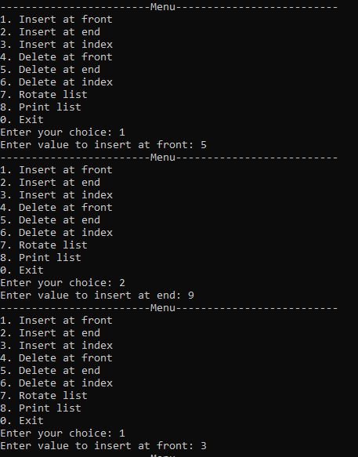
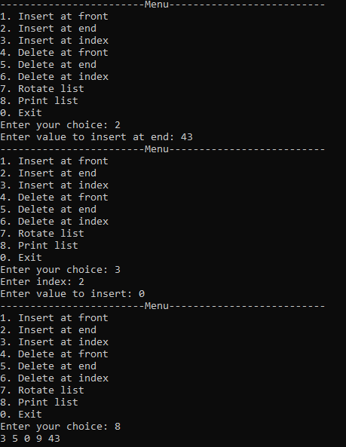
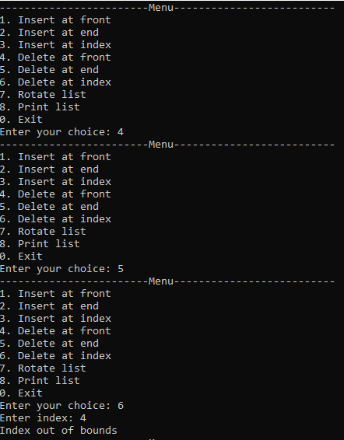
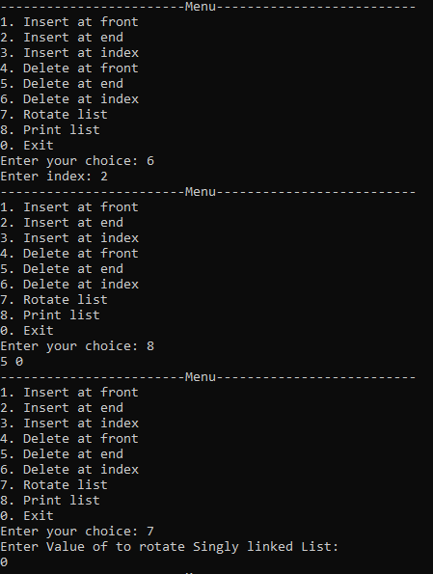
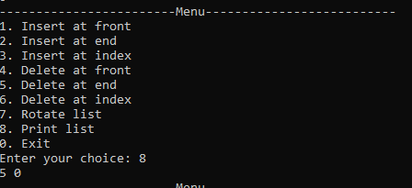
Task 5
#include<iostream>
using namespace std;

struct Node {
int data;
Node* next;
Node* prev;
};

class DoublyLinkedList {
public:
DoublyLinkedList();
void Insert_at_front(int val);
void Insert_at_end(int val);
void Insert_at_index(int index, int val);
void Delete_at_front();
void Delete_at_end();
void Delete_at_index(int index);
int middleDoubly();
bool Isempty();
void Print();
~DoublyLinkedList();

private:
Node* head;
Node* tail;
};

DoublyLinkedList::DoublyLinkedList() {
head = NULL;
tail = NULL;
}

bool DoublyLinkedList::Isempty() {
return head == NULL;
}

void DoublyLinkedList::Insert_at_front(int val) {
if (Isempty()) {
head = new Node;
head->data = val;
head->next = NULL;
head->prev = NULL;
tail = head;
}
else {
Node* temp = new Node;
temp->data = val;
temp->next = head;
head->prev = temp;
temp->prev = NULL;
head = temp;
}
}

void DoublyLinkedList::Insert_at_end(int val) {
if (Isempty()) {
head = new Node;
head->data = val;
head->next = NULL;
head->prev = NULL;
tail = head;
}
else {
Node* temp = new Node;
temp->data = val;
temp->next = NULL;
temp->prev = tail;
tail->next = temp;
tail = temp;
}
}

void DoublyLinkedList::Insert_at_index(int index, int val) {
if (Isempty()) {
if (index == 0) {
head = new Node;
head->data = val;
head->next = NULL;
head->prev = NULL;
tail = head;
}
else {
cout << "Index out of bounds" << endl;
return;
}
}
else {
Node* current = head;
int currentIndex = 0;
while (current->next != NULL && currentIndex < index - 1) {
current = current->next;
currentIndex++;
}
if (currentIndex == index - 1) {
Node* newNode = new Node;
newNode->data = val;
newNode->next = current->next;
newNode->prev = current;
current->next = newNode;
if (newNode->next != NULL) {
newNode->next->prev = newNode;
}
else {
tail = newNode;
}
}
else {
cout << "Index out of bounds" << endl;
}
}
}

void DoublyLinkedList::Delete_at_front() {
if (Isempty()) {
cout << "List is empty" << endl;
return;
}
else {
Node* temp = head;
head = head->next;
if (head != NULL) {
head->prev = NULL;
}
else {
tail = NULL;
}
delete temp;
}
}

void DoublyLinkedList::Delete_at_end() {
if (Isempty()) {
cout << "List is empty" << endl;
return;
}
else if (head->next == NULL) {
delete head;
head = NULL;
tail = NULL;
}
else {
Node* current = head;
while (current->next->next != NULL) {
current = current->next;
}
Node* temp = current->next;
current->next = NULL;
tail = current;
delete temp;
}
}

void DoublyLinkedList::Delete_at_index(int index) {
if (Isempty()) {
cout << "List is empty" << endl;
return;
}
else if (index == 0) {
Node* temp = head;
head = head->next;
if (head != NULL) {
head->prev = NULL;
}
else {
tail = NULL;
}
delete temp;
}
else {
Node* current = head;
int currentIndex = 0;
while (current->next != NULL && currentIndex < index - 1) {
current = current->next;
currentIndex++;
}
if (currentIndex == index - 1) {
Node* temp = current->next;
current->next = current->next->next;
if (current->next != NULL) {
current->next->prev = current;
}
else {
tail = current;
}
delete temp;
}
else {
cout << "Index out of bounds" << endl;
}
}
}

void DoublyLinkedList::Print() {
Node* current = head;
while (current != NULL) {
cout << current->data << " ";
current = current->next;
}
cout << endl;
}

DoublyLinkedList::~DoublyLinkedList() {
Node* current = head;
while (current != NULL) {
Node* next = current->next;
delete current;
current = next;
}
}

int DoublyLinkedList::middleDoubly() {
if (Isempty()) {
cout << "List is empty" << endl;
return -1;
}

Node* slow = head;
Node* fast = head;
while (fast != NULL && fast->next != NULL) {
slow = slow->next;
fast = fast->next->next;
}

return slow->data;
}

int main() {
DoublyLinkedList DLL;
int choice, val, index;

while (true) {
cout << "------------------------Menu--------------------------" << endl;
cout << "Press 1 to Insert at front" << endl;
cout << "Press 2 to Insert at end" << endl;
cout << "Press 3 to Insert at index" << endl;
cout << "Press 4 to Delete at front" << endl;
cout << "Press 5 to Delete at end" << endl;
cout << "Press 6 to Delete at index" << endl;
cout << "Press 7 to Print list" << endl;
cout << "Press 8 to Find middle element" << endl; // New option
cout << "Press 0 to Exit" << endl;
cout << "Enter your choice: ";
cin >> choice;

switch (choice) {
case 1:
cout << "Enter value to insert at front: ";
cin >> val;
DLL.Insert_at_front(val);
break;
case 2:
cout << "Enter value to insert at end: ";
cin >> val;
DLL.Insert_at_end(val);
break;
case 3:
cout << "Enter index: ";
cin >> index;
cout << "Enter value to insert: ";
cin >> val;
DLL.Insert_at_index(index, val);
break;
case 4:
DLL.Delete_at_front();
break;
case 5:
DLL.Delete_at_end();
break;
case 6:
cout << "Enter index: ";
cin >> index;
DLL.Delete_at_index(index);
break;
case 7:
DLL.Print();
break;
case 8:
int middle = DLL.middleDoubly();
if (middle != -1) {
cout << "The middle element is: " << middle << endl;
}
break;
case 0:
return 0;
default:
cout << "Invalid choice. Try again." << endl;
}
}

return 0;
}
Task 6
#include<iostream>
using namespace std;

struct Node {
int data;
Node* next;
Node* prev;
};

class DoublyLinkedList {
public:
DoublyLinkedList();
void Insert_at_front(int val);
void Insert_at_end(int val);
void Insert_at_index(int index, int val);
void Delete_at_front();
void Delete_at_end();
void Delete_at_index(int index);
bool Isempty();
void Print();
bool palindromeDoubly();
~DoublyLinkedList();

private:
Node* head;
Node* tail;
};

DoublyLinkedList::DoublyLinkedList() {
head = NULL;
tail = NULL;
}

bool DoublyLinkedList::Isempty() {
return head == NULL;
}

void DoublyLinkedList::Insert_at_front(int val) {
if (Isempty()) {
head = new Node;
head->data = val;
head->next = NULL;
head->prev = NULL;
tail = head;
}
else {
Node* temp = new Node;
temp->data = val;
temp->next = head;
head->prev = temp;
temp->prev = NULL;
head = temp;
}
}

void DoublyLinkedList::Insert_at_end(int val) {
if (Isempty()) {
head = new Node;
head->data = val;
head->next = NULL;
head->prev = NULL;
tail = head;
}
else {
Node* temp = new Node;
temp->data = val;
temp->next = NULL;
temp->prev = tail;
tail->next = temp;
tail = temp;
}
}

void DoublyLinkedList::Insert_at_index(int index, int val) {
if (Isempty()) {
if (index == 0) {
head = new Node;
head->data = val;
head->next = NULL;
head->prev = NULL;
tail = head;
}
else {
cout << "Index out of bounds" << endl;
return;
}
}
else {
Node* current = head;
int currentIndex = 0;
while (current->next != NULL && currentIndex < index - 1) {
current = current->next;
currentIndex++;
}
if (currentIndex == index - 1) {
Node* newNode = new Node;
newNode->data = val;
newNode->next = current->next;
newNode->prev = current;
current->next = newNode;
if (newNode->next != NULL) {
newNode->next->prev = newNode;
}
else {
tail = newNode;
}
}
else {
cout << "Index out of bounds" << endl;
}
}
}

void DoublyLinkedList::Delete_at_front() {
if (Isempty()) {
cout << "List is empty" << endl;
return;
}
else {
Node* temp = head;
head = head->next;
if (head != NULL) {
head->prev = NULL;
}
else {
tail = NULL;
}
delete temp;
}
}

void DoublyLinkedList::Delete_at_end() {
if (Isempty()) {
cout << "List is empty" << endl;
return;
}
else if (head->next == NULL) {
delete head;
head = NULL;
tail = NULL;
}
else {
Node* current = head;
while (current->next->next != NULL) {
current = current->next;
}
Node* temp = current->next;
current->next = NULL;
tail = current;
delete temp;
}
}

void DoublyLinkedList::Delete_at_index(int index) {
if (Isempty()) {
cout << "List is empty" << endl;
return;
}

if (index < 0) {
cout << "Index cannot be negative" << endl;
return;
}

if (index == 0) {
Node* temp = head;
head = head->next;
if (head != nullptr) {
head->prev = nullptr;
}
else {
tail = nullptr;
}
delete temp;
}
else {
Node* current = head;
int currentIndex = 0;

while (current != nullptr && currentIndex < index - 1) {
current = current->next;
currentIndex++;
}

if (current == nullptr || current->next == nullptr) {
cout << "Index out of bounds" << endl;
return;
}
Node* temp = current->next;
current->next = temp->next;
if (temp->next != nullptr) {
temp->next->prev = current;
}
else {
tail = current;
}
delete temp;
}
}

void DoublyLinkedList::Print() {
Node* current = head;
while (current != NULL) {
cout << current->data << " ";
current = current->next;
}
cout << endl;
}

bool DoublyLinkedList::palindromeDoubly() {
if (Isempty() || head->next == nullptr) {
return true;
}

Node* slow = head;
Node* fast = head;
while (fast != nullptr && fast->next != nullptr) {
slow = slow->next;
fast = fast->next->next;
}
Node* secondHalf = slow;
Node* prev = nullptr;
Node* current = secondHalf;
Node* next = nullptr;

while (current != nullptr) {
next = current->next;
current->next = prev;
current->prev = next;

prev = current;
current = next;
}

secondHalf = prev;
Node* firstHalf = head;
while (secondHalf != nullptr) {
if (firstHalf->data != secondHalf->data) {
return false;
}
firstHalf = firstHalf->next;
secondHalf = secondHalf->next;
}

return true;
}

DoublyLinkedList::~DoublyLinkedList() {
Node* current = head;
while (current != NULL) {
Node* next = current->next;
delete current;
current = next;
}
}

int main() {
DoublyLinkedList DLL;
int choice, val, index;

while (true) {
cout << "------------------------Menu--------------------------" << endl;
cout << "1. Insert at front" << endl;
cout << "2. Insert at end" << endl;
cout << "3. Insert at index" << endl;
cout << "4. Delete at front" << endl;
cout << "5. Delete at end" << endl;
cout << "6. Delete at index" << endl;
cout << "7. Check if list is palindrome" << endl;
cout << "8. Print list" << endl;
cout << "0. Exit" << endl;
cout << "Enter your choice: ";
cin >> choice;

switch (choice) {
case 1:
cout << "Enter value to insert at front: ";
cin >> val;
DLL.Insert_at_front(val);
break;
case 2:
cout << "Enter value to insert at end: ";
cin >> val;
DLL.Insert_at_end(val);
break;
case 3:
cout << "Enter index: ";
cin >> index;
cout << "Enter value to insert: ";
cin >> val;
DLL.Insert_at_index(index, val);
break;
case 4:
DLL.Delete_at_front();
break;
case 5:
DLL.Delete_at_end();
break;
case 6:
cout << "Enter index: ";
cin >> index;
DLL.Delete_at_index(index);
break;
case 7:
if (DLL.palindromeDoubly()) {
cout << "The list is a palindrome." << endl;
}
else {
cout << "The list is not a palindrome." << endl;
}
break;
case 8:
DLL.Print();
break;
case 0:
return 0;
default:
cout << "Invalid choice. Try again." << endl;
}
}

return 0;
}
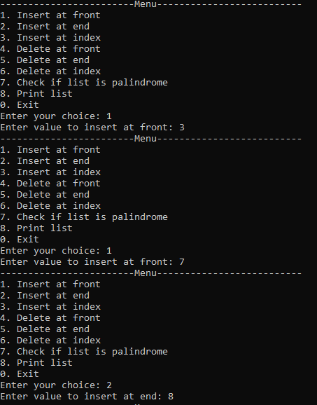
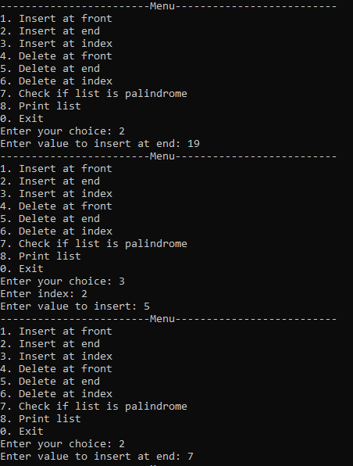
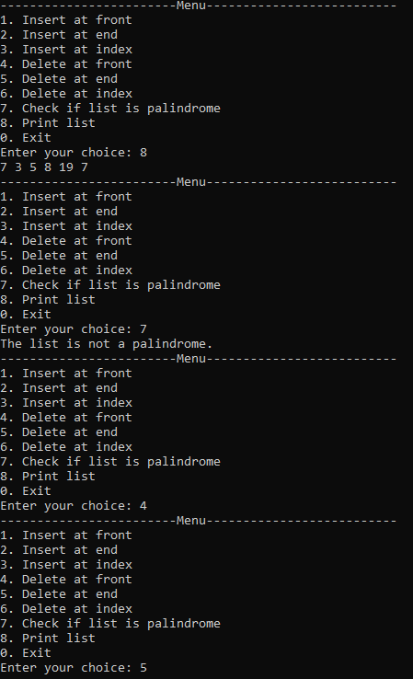
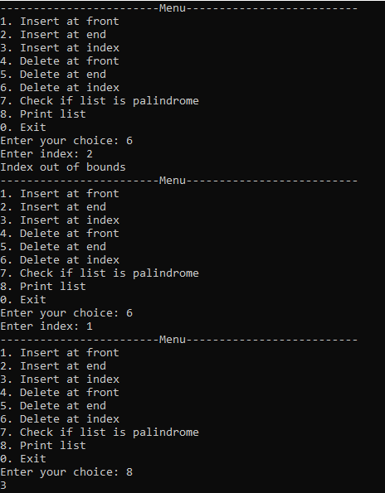
Task 7

